ENTRANCE

For where two or three are gathered in my name, I am there among them. (Matthew 18:20^{NRSV})
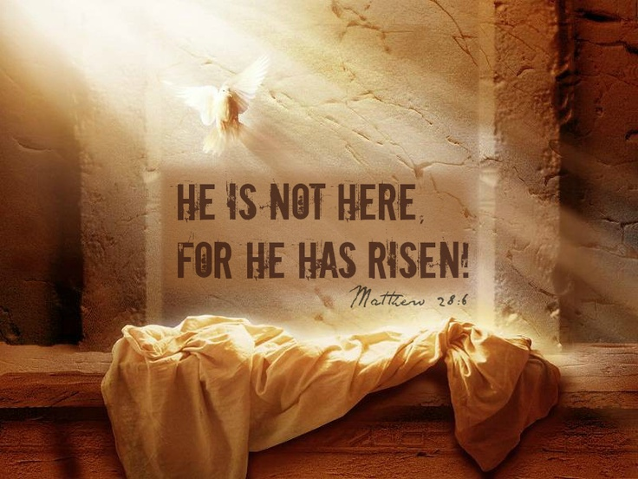

Welcome & Announcements Ricky Tipps
*Opening prayer Pastor
*Call to Worship (Responsively) Pastor
Alleluia! Christ is risen.
Christ is risen, indeed!
This is the day the Lord has made.
Let us rejoice and be glad in it!
Alleluia! Christ is risen.
Christ is risen! Christ is risen! Christ is risen, indeed!
*Hymn “Christ the Lord Is Risen Today” #270 BH
*Hymn “Christ Arose” #273 BH
PROCLAMATION OF THE WORD
Gospel Reading Luke 24:1-12; Pastor
Concerns and Prayers/Lord’s Prayer Pastor
Special Music David Cost
Special Music David Piatt

Sermon Luke 24:1-12; Pastor

“Christ is Risen Indeed!”
RESPONSE TO THE WORD
Hymn “Alleluia! Alleluia!” #272 BH
*Confession of Sins (Unison)
God of life and love, we rejoice in our own salvation, but find it hard to forgive those who have hurt us. You call us to seek the paths of peace and blessing, to be Your face to everyone we meet, but it is easier sticking to well-traveled streets of anger and resentment. You call us to spread Your word of resurrection, to witness to Your love and grace for the world, but our lips remain silent. Forgive us, Holy One, when we hold on to what we have, rather than share Your gifts with the world. Amen.
*Words of Assurance
Brothers and sisters, we are witnesses to the resurrection story. As witnesses, may we find hope in Christ and be assured of God’s grace, forgiveness, and steadfast love in the life and death. Praise and thanks be to God! Amen.
Receiving a New Member Victoria Fox
*Affirmation of Faith
The Celebration of the Holy Communion Pastor

SENDING FORTH
*Closing Hymn “He Lives” #269 BH
*Charge & Benediction Pastor
With Mary and the Disciples and all those who live in Christ,
let us rejoice that we have seen our Savior, who is not dead, but lives.
In the love of the Creator; in the life, death, and resurrection of Jesus Christ; and the power of the Holy Spirit, let us go forth to love and serve the world.
Christ is risen, Christ is risen, Christ is risen, indeed!
Alleluia! Amen.
Postlude Phyllis Turner

In the Life of our Stonegate Family

Thursday, April 21, 2022  10:00 a.m. – Women’s Bible Study  Friday, April 22, 2022  9:00 a.m. – Friday Morning Breakfast | Sunday, April 24, 2022  10:45 a.m. – Sunday Worship

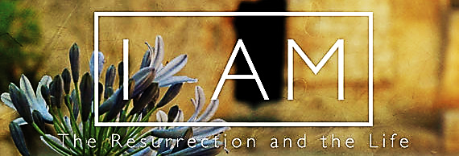
For Our Guests
We are so thrilled to have you worship with us today. We truly hope you are encouraged and inspired to grow closer to God as we worship the true and living God together.

Some prayers, litanies, and other worship resources or their parts used in bulletin, except as noted, come: “From The Abingdon Worship Annual 2017 Edition, edited by Mary J. Scifres and B. J. Beu. Copyright © 2015 by Abingdon Press. Used by permission.” and others come from unrecognized, unnamed resources, or are our own ideas.

WORSHIP LEADERS  Rev. Dr. Mark Marian Sontowski, Pastor  Phyllis Turner, Pianist  David Piatt, Pam Brown & Andy Turner, Worship Leaders  David Cost & David Piatt, Soloists  Ricky Tipps, Welcome and Announcements | * Please rise as you are able  #156 BH = Page 156 Blue Hymnal  17101 North Western, Edmond, Oklahoma 73012  www.stonegatecpc.org  Office 405-340-7281 Pastor 405-315-4895

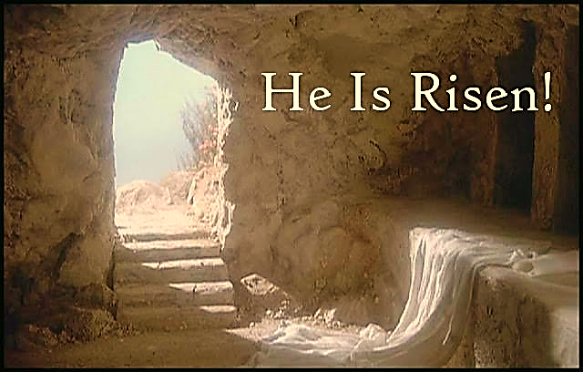
Theme Ideas
Despite appearances, death does not have the last word. The truth of God’s love is revealed in the life, death, and resurrection of Jesus; in the life of the Church; and in our
lives today. Christ is Risen! Alleluia!

Stonegate Church
Cumberland Presbyterian

Sunday Worship Service at 10:45 am
The Resurrection Of The Lord; Easter Sunday, April 17, 2022

Experience the Love of Christ in Community!

